**Quick PC**

*PC Building Assistance Mobile Application*



**Prototype Documentation**

CECS 491A T/TH 12:30 PM

# **Table of Contents**

**Table of Contents** **1**

**Summary** **2**

**Welcome Page** **3**

**Login Page** **4**

**User Registration Page** **5**

**Home Page** **6**

**Search Page** **7**

**PC Information Page** **8**

**Developer Guide** **9**

**User Manual** **9**

# 

# 

# 

# 

# 

# 

# 

# **Summary**

Quick PC is a mobile application written in Dart using Flutter. The application is designed to help users compare prices and compatibility of PC components. In this documentation, we explained what each page does such as login, user registration, home, search, pc information.

Our prototype implemented Firebase authentication for user sign in information and we created a development environment for our application using GitHub.

# **Welcome Page**

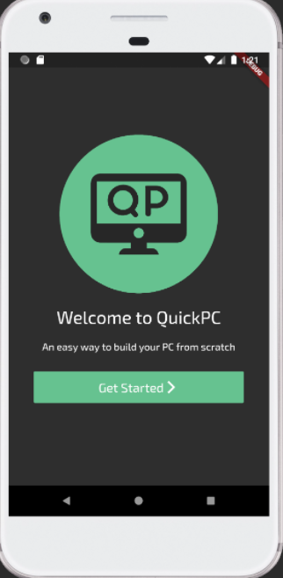

When the user first opens the application, they are prompted with a welcome page. Our welcome page consists of our logo and motto. The user is able to access the login and registration phase of the application after they click “Get Started”. If the user already has an account, they can login using their existing account. However, if they don’t have an account, they can register using a unique email and password.

# **Login Page**

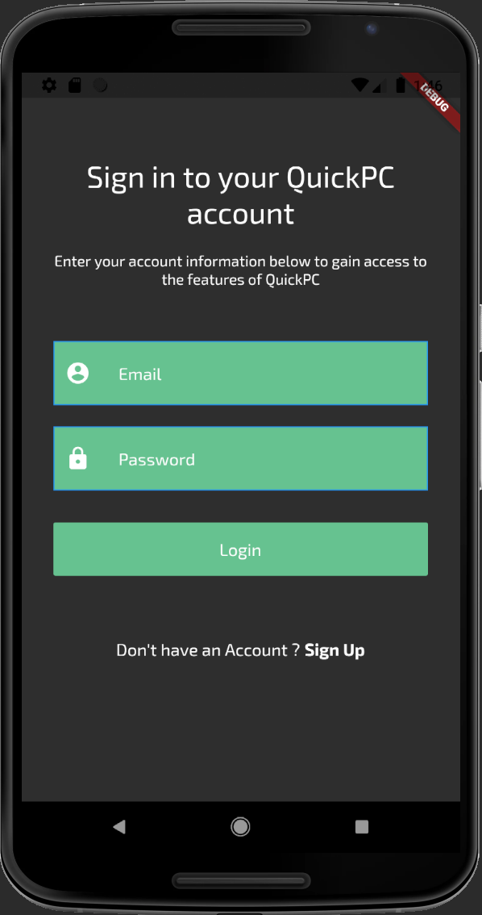

This is what the user is greeted after they clicked “Get Started”. They are directed to a screen with two options: Log into the application with their account information, prompting the user to enter their current username and password associated with their account. The second option below the login button is the option to create a new account if they do not currently have a QuickPC account. User accounts are authenticated and stored on the Firebase cloud linked to our project. The database checks to see if the account exists when a user tries to log in using Firebase authentication by checking the email and password.

## 

# **User Registration Page**

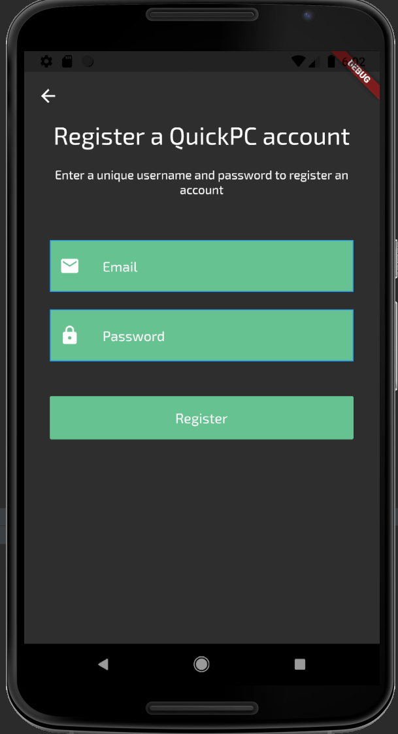

If a user does not currently have a QuickPC account, they can create an account through the application by clicking the “Sign Up” button on the login page. Once clicked, the user is directed to the registration page that’ll require the user to enter a unique email and password. The email field cannot be empty and must be a valid email. The email is validated through a Firebase authentication function that creates a user account with an email and password. The password a user enters must also be at least 6 characters long. The function returns a user with a unique user ID. Once registered, the user will be able to access all the features from QuickPC such as search for parts, build pc, suggest pc, build guides, account, contact us, and about us.

# **Home Page**

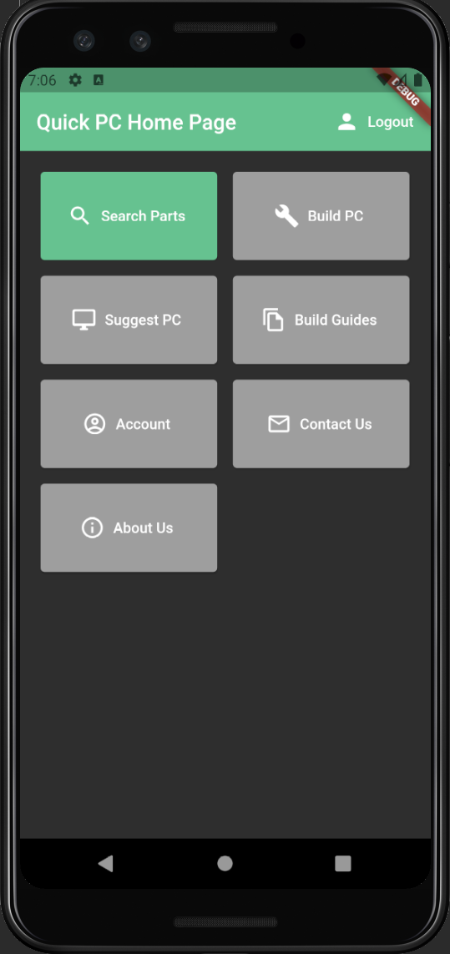

Our home page consists of all the features in the QuickPC application. We made sure to design the UI as easy to navigate as possible. In the home page we have 7 total features: search for parts, build PC, suggest PC, build guides, account, contact us, and about us.

1. Search for parts
   1. Browse by specific parts that can be filtered by price, manufacturer, and ratings
2. Build PC
   1. Allows users to browse a list of parts to create their own PC
3. Suggest PC based on
   1. The user can set a price range for their budget
   2. Users can specify if they are using the PC for gaming or work
4. Build Guides
   1. Step-by-step PC building guide integrated in the application
   2. Informative guide on the steps needed to assemble a PC
5. Account
   1. Allows users to view their saved builds and reset password
6. Contact Us
   1. Allows users to submit a feedback or report a bug
7. About Us
   1. Information on the goal of the application and how it came to be

# **Search Page**

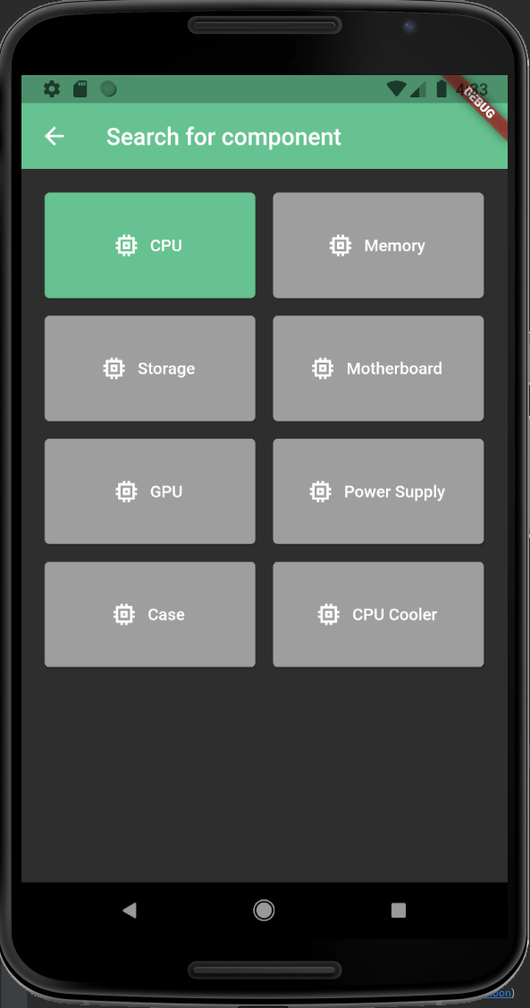

After selecting the “Search Parts” option the user can decide what type of component to search for. Currently The Search List page pulls data from our Firebase database where we stored test data for CPUs. Each CPU is presented in a card with its name, price and clock speed. There are tabs that would give the user the option to select filters and comparisons. From here the user can select a specific PC component and get taken to the parts info page.

# **PC Information Page**

After selecting a specific component, the user is presented with the information for that part’s specifications. There are tabs to see different prices and reviews.

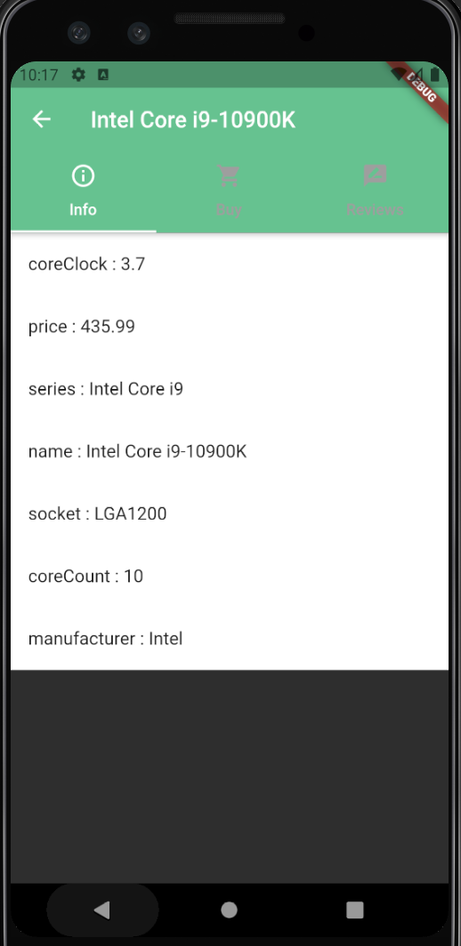

# **Developer Guide**

The developer guide documentation consists of an overview of our project, the components we used to create our project, project documentation resources, tools to successfully set up the project, development process, and development support. A link to the documentation is provided below.

Link: [Developer Guide](https://docs.google.com/document/d/1t2WsCFB3PvqoiwsaFACskSilRE4ZEpAaKn8eG7Uh0vM/edit?usp=sharing)

# **User Manual**

The user manual documentation consists of a project overview and a guide on how to access certain features of our application such as logging in, registering, accessing the homepage functionalities, searching for a specific part, and viewing specific details of each component. A link to the documentation is provided below.

Link: [User Manual](https://docs.google.com/document/d/1cDekqF34wxRpeZgPZH8II96FAWMEbbRqf9d8UM4r8Fk/edit?usp=sharing)